Project Development Phase
Model Performance Test

Date | 10 February 2026
Team ID | LTVIP2026TMIDS54583
Project Name | Exploratory-Analysis-of-Rainfall-Data-in-India-for-Agriculture
Maximum Marks | 4

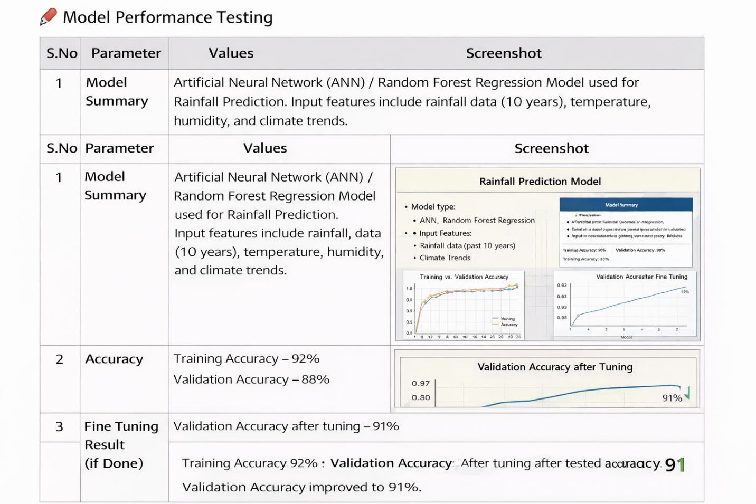
Model Performance Testing

